**SMART GLASS FOR BLIND PEOPLE**

**Project Requirements**

**Aim:**

There are a number of problems and challenges that physically challenged people faces in their day to day lives. One of the biggest challenges faced by blind people is the inability to read. For the purpose of assisting the visually challenged people in reading, a Raspberry Pi based reader for the blind project is proposed the project consists, an audio speaker,gps, ultrasonic sensors and a digital camera. This device helps the blind people to easily feel the obstacles in front of them and can save them from accidents. All these devices are interfaced with the Raspberry Pi. The camera takes the image of the paper and passes it on to the Raspberry Pi. The Raspberry Pi applies OCR image processing algorithms to the image and converts the text to the speech. The speaker outputs the audio speech. Ultrasonic sensors detect the obstacles in front of it and give indication through speaks. When pressing switch he can hear the location that person stands. When pressing another switch then location data and image of that location will sends to parents and lifesaving units

**Hardware & Software Requirements:**

1. RASPBERRY PI
2. python
3. ULTRASONIC SENSOR-3
4. CAMERA
5. GPS
6. SPEAKER
7. Power supply
8. Transformer
9. 5v adapter
10. SWITCH-2
    1. **Project Flow:**

SPEAKER

raspberrypi

ULTRASONIC-3

ULTRASONIC-2

ULTRASONIC-1

SWITCH-1

SWITCH-2

Cloud

camera

GPS

Power supply

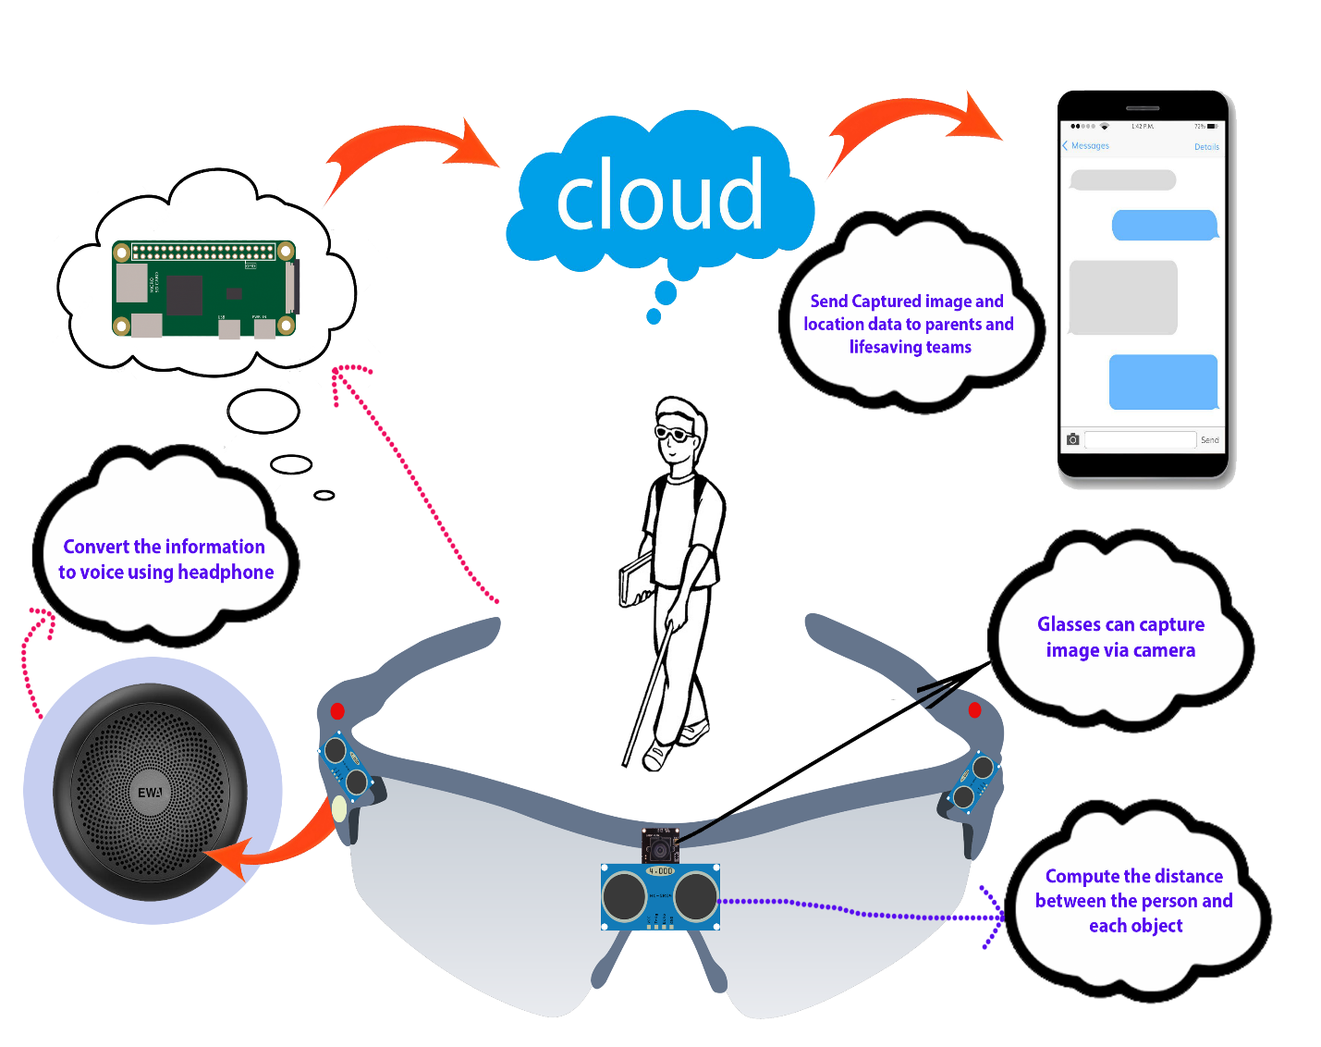

**OBJECTIVE:**

1. Main purpose of this product is to help blind people see, not literally but make life a little bit easier for them
2. Glasses can capture image via camera
3. Glasses can recognize images and determine each object in the images
4. Compute the distance between the person and each object
5. Convert the information to voice using headphone
6. Send Captured image and location data to parents and lifesaving teams